**ASSIGNMENT 1**

**Submitted by: Anusha Lathi**

− Report View

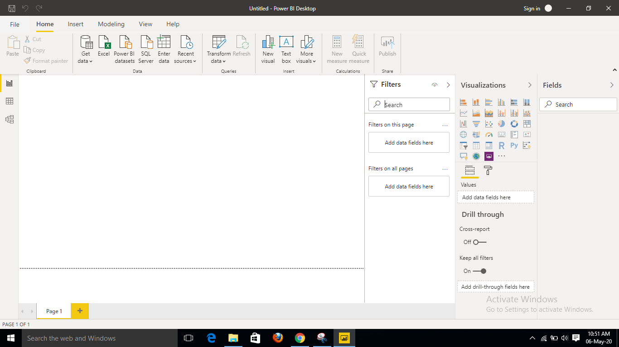

− Data View

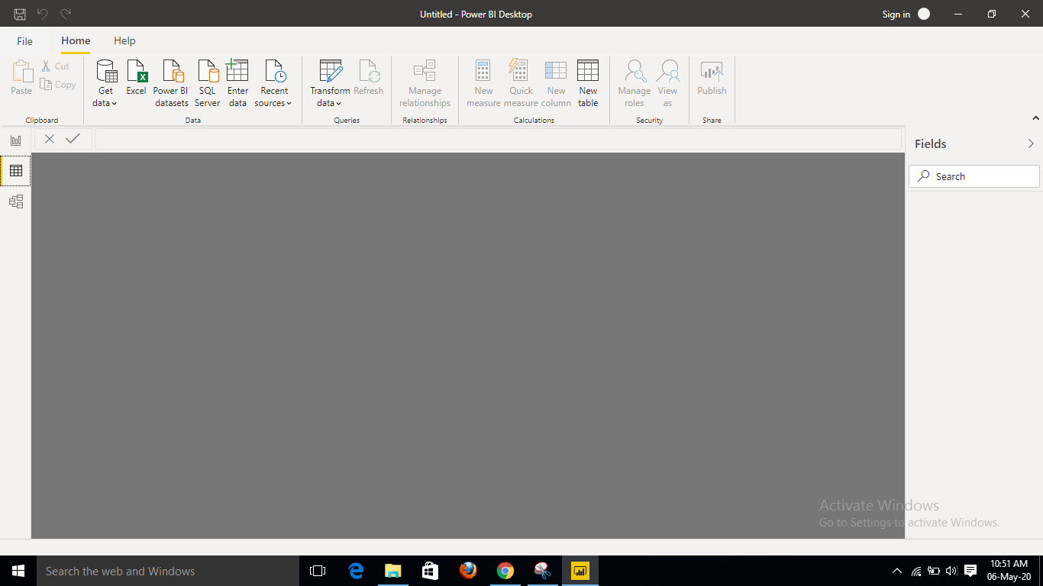

− Model View

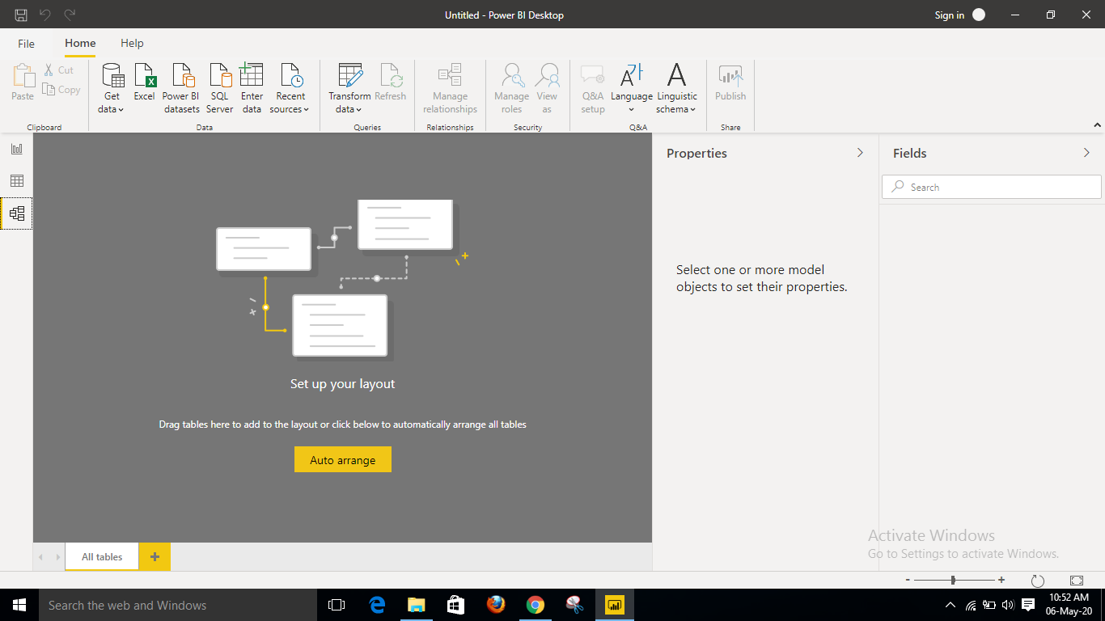

− Power Query Editor

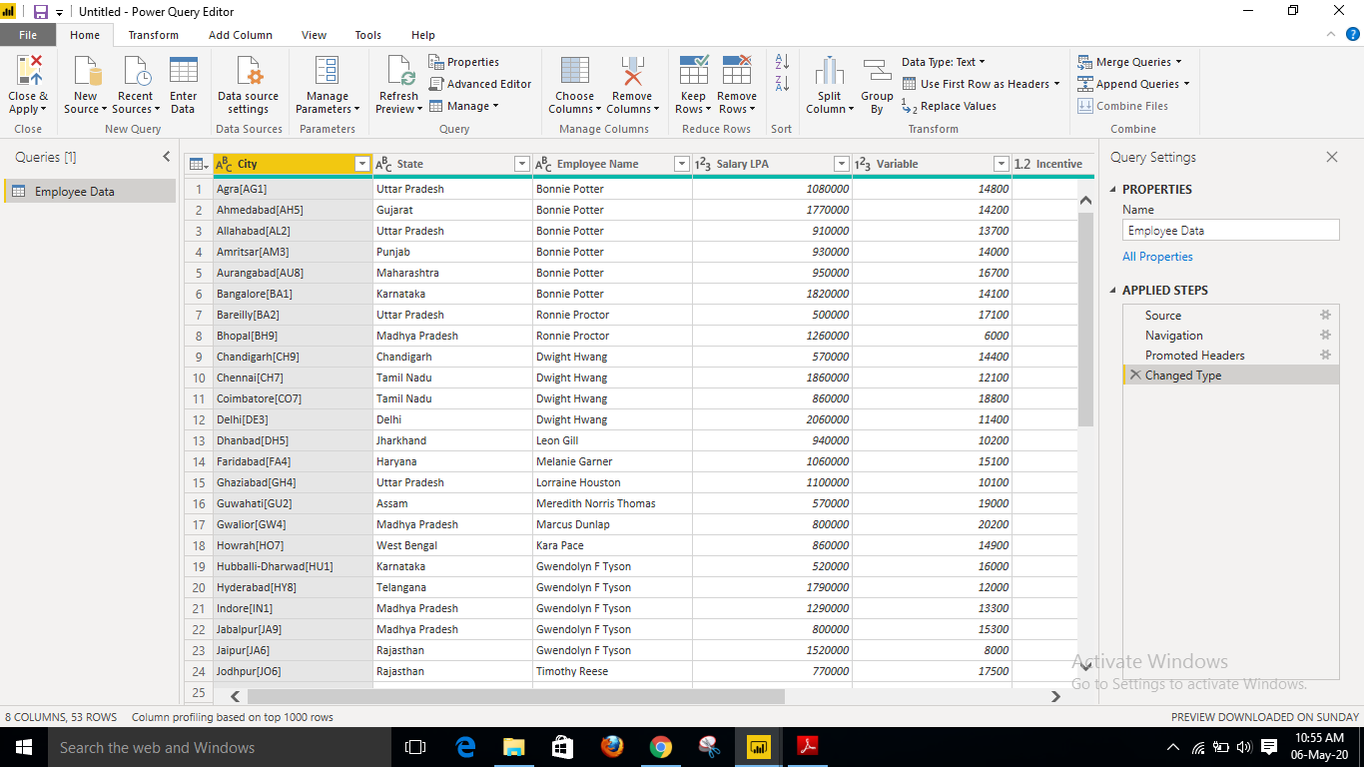

− Advance Editor

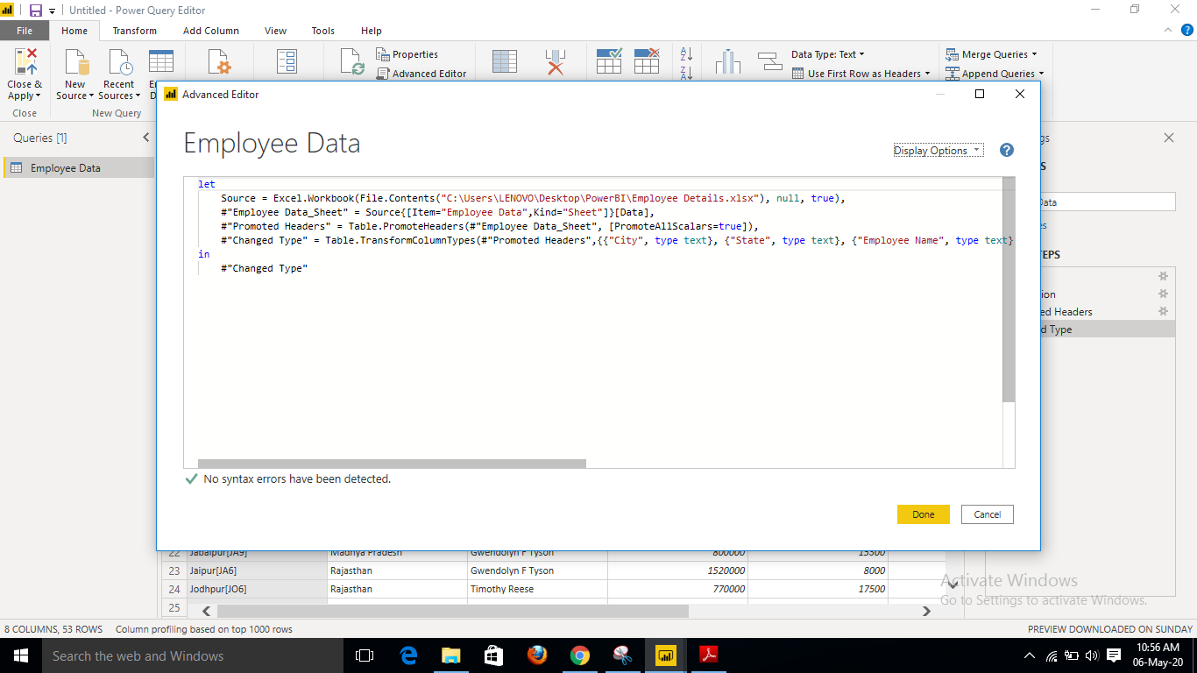

− Power BI Desktop (Product price: Free for a single user)

Power BI Desktop is a free application you install on your local computer that lets you connect to, transform, and visualize your data. With Power BI Desktop, you can connect to multiple different sources of data, and combine them (often called modeling) into a data model. This data model lets you build visuals, and collections of visuals you can share as reports, with other people inside your organization. Most users who work on business intelligence projects use Power BI Desktop to create reports, and then use the Power BI service to share their reports with others.

The most common uses for Power BI Desktop are as follows:

* Connect to data
* Transform and clean that data, to create a data model
* Create visuals, such as charts or graphs, that provide visual representations of the data
* Create reports that are collections of visuals, on one or more report pages
* Share reports with others by using the Power BI service

People most often responsible for such tasks are often considered *data analysts* (sometimes referred to as *analysts*) or business intelligence professionals (often referred to as *report creators*). However, many people who don't consider themselves an analyst or a report creator use Power BI Desktop to create compelling reports, or to pull data from various sources and build data models, which they can share with their coworkers and organizations.

There are three views available in Power BI Desktop, which you select on the left side of the canvas. The views, shown in the order they appear, are as follows:

* **Report**: In this view, you create reports and visuals, where most of your creation time is spent.
* **Data**: In this view, you see the tables, measures, and other data used in the data model associated with your report, and transform the data for best use in the report's model.
* **Model**: In this view, you see and manage the relationships among tables in your data model.

− Power BI Pro (Product price: $9.99/user/month)

Power BI Pro is the full version of Power BI, which means it comes complete with the ability to use Power BI for both building dashboards, reports and unlimited viewing, sharing and consumption of your created reports (and reports shared by others) which is not possible with Power BI Desktop.The biggest difference of Power BI Pro vs. Free is the fact that with Pro you have the option and the ability to share the data, reports, and dashboards with a large number of other users that also have a Power BI Pro license while also being able to create an app based workspace. Furthermore, in Power BI Pro vs. Free you have a 10 GB per Pro user data storage limit.

Primarily, Power BI Pro vs. Free is licensed by individual users. This means that for you to use Power BI Pro in your organisations means each individual will receive their won Power BI Pro license and the collaborative use of which will allow every member of the organisation to integrate their workspace and therefore, their efforts. In other words, if your organisation has 10 people that need the full capabilities offered by Power BI Pro to create dashboards and reports, you require 10 licenses of Power BI Pro. If you have a much greater quantity of user, Power BI Premium would be a better idea considering the scale of operations as eventually, the cost will far exceed the benefits.

− Power BI Premium (Product price: $4,995 a month per dedicated cloud compute and storage resource.)

The Power BI Premium license is not a per-user license like a Free or Pro License. Instead, Power BI Premium license provides a dedicated unit of capacity for all users in the organization. This dedicated capacity (aka Premium Workspace) can be used to host large datasets up to 50GB while offering a total storage of 100TB in the cloud. It enables your organization to use your own dedicated capacity and hardware rather than relying on Microsoft’s shared capacity. Although you will in fact need to determine said capacity accurately and ensure that it has the capabilities to handle your reporting and analysis needs. This allows for much larger scale and better performance if you size the capacity properly. Microsoft offers three sizes for Premium capacity and each come with a different number of v-cores and memory size.

## Power BI Premium is for use in large organizations with a great number of users that need to collaborate in real time. The application is geared towards addressing the challenges of large enterprise deployments and workloads.